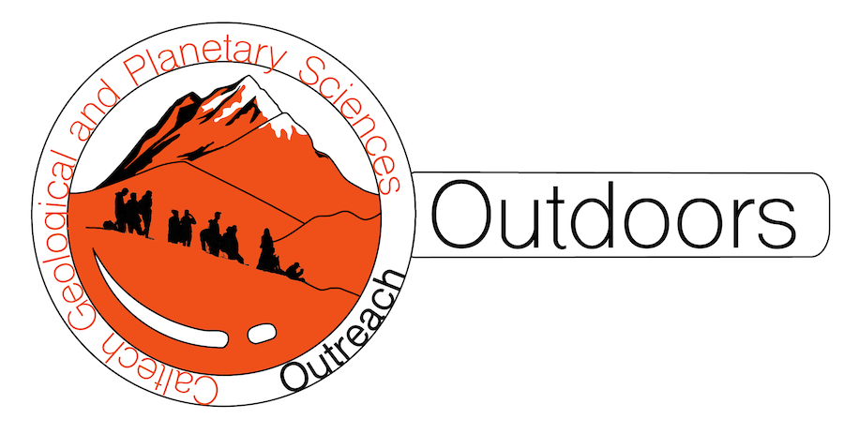
*Note: sections of the lesson plan template marked with * are optional, but may be useful for your planning.
The Scale of the Solar System!
Grade level | 6-8
Standards | MS-ESS1-3. Analyze and interpret data to determine scale properties of objects in the solar system.
Goals | - Students will use information about the planets to hypothesize about their relative sizes and distances from the Sun  - Students will deduce the relative sizes of the planets based on information about their properties  - Students will create a scale model of the distances between planets and compare with real values
Time | 1 hour
# students | 8+
Materials | - Poster boards & velcro cutouts of planets  - Roll of receipt paper  - Markers
Location | Classroom with a whiteboard
Logistics | For a shorter lesson, just the first part (relative sizes of the planets) can be done. For a full-length lesson, after the relative planet sizes activity is finished, the students can break up from their groups and the receipt paper and markers are handed out
Caltech student needed? | No, but the Caltech student can provide the supplies, help with leading the lesson, and answer questions
Accessibility | An optional extended activity includes a video illustrating the scale of the solar system, which requires a projector/way to display the video to the class
Lesson activities
Engage: (25 min)
- Start with introductions and an explanation of what we’ll be learning about: the sizes of the different planets in the solar system and the distances between planets. Tell them why it matters: the Earth is our home in space but there is a big and wild universe out there, humanity may have started on Earth but we may not finish here. Intros can include everyone’s name and favorite planet.
- Begin by asking the class about their experiences with the planets:
  - Have they ever seen Jupiter or Mars in the night sky? Instructors can explain which planets are visible in the night sky around the time of the lesson and how students can identify them
  - What have they seen about the planets in the news? Have they watched the rocket launches or rover landings on Mars, or seen the pictures from missions around Jupiter and Saturn? (Some of these photos could be projected)
- Split the class into 8 groups and assign each of them a posterboard with cutouts of the planets that will be stuck to the board during the activity
- Introduce the cutouts of the eight planets of the solar system. The left side of each posterboard is labeled as the Sun, with 8 velcro points on the poster for each planet, labeled by name. Tell the students that they will have to do some astronomy detective work to assign the blank planet cutouts to the right spots by using the clues that will be provided.
- The cutouts are blank and unlabeled so that it’s not clear which planet is which, other than by figuring them out from their relative sizes. The cutouts are be circular and proportioned with their diameter as follows: 2 & ¼ inch (Mercury), 5 & ¼ inch (Venus), 6 inches (Earth), 3 & ⅜ inch (Mars), 33 inches (Jupiter), 30 inches (Saturn), 12 inches (Uranus), 11 ¼ inch (Neptune)
- Emphasize that the relative radii of the planets ARE to scale, but the distances between planets ARE NOT.
- First clue: four of the planets are made of gas, and four of the planets are made of rock & metal. Ask the class if they think the planets made of rock & metal are the 4 smaller ones, or the larger ones? Why? (The lower density of gas means that it can expand outwards and fill a larger space than the tightly packed solid atoms in metal & rock, so the larger planets are all mostly made of gas). Now ask the students if they think the gaseous planets are the closest ones to the Sun, or the furthest away? Why? (Radiation from the Sun blasts away the atmospheres of planets, so the gas planets are more likely to survive further out)
  - The students will now stick the four larger cutouts on either the left four spaces or the right four spaces on the cutout, with the specifics to be rearranged later.
- Now we change focus to the smaller four cutouts. Tell the students that two of the rocky planets don’t have much of an atmosphere, but the other two do. Ask them if they think the planets without an atmosphere will be smaller or larger than the planets that do. Why? (The planets with an atmosphere are larger. They aren’t actually larger because they have an atmosphere - they have an atmosphere because they are larger. A larger, more massive planet creates stronger gravity to prevent the atmosphere from escaping to space). Tell the students that Earth and Venus are the rocky planets with atmospheres, so now the students will pick either the smaller two or larger two and stick them on the Earth/Venus spots
- Now focus on the smaller two of the terrestrial planets, the ones without any atmosphere. Tell the students that the smaller of the two planets is very hot, while the larger one is very cold. Do they think that the smaller/hotter planet is closer to the sun, or further away? Why? (The smaller hotter one is Mercury because it is closer to the Sun and receives more sunlight, Mars is the larger cutout and is further away from the Sun and colder). Have the students pin the two cutouts to a final spot
- Now focus on the larger two rocky planet cutouts. Tell them that the larger one is much hotter than the smaller one, and ask which planets they think they are. (The larger and hotter one is Venus, which the students may guess because it’s closer to the Sun. The actual reason why Venus is so much hotter is because it’s atmosphere is so thick and has a greenhouse effect). Ask the students if they want to switch the locations of the cutouts for Mercury and Mars with this new information.
- The smaller four rocky planets should now all be stuck to the posterboard for each group. Now turn the class attention towards the four larger cutouts, and mention that two of the planets have many very large moons, while the other two planets don’t have many moons. Do they think the planets with lots of moons are the larger ones or the smaller ones? Why? (The planets with lots of moons are the larger ones, they have more mass and stronger gravity to capture moons in their orbit). Jupiter and Saturn have lots of moons, so now the students can pick the cutouts they stick on those spots.
- Focusing just the largest two cutouts now, mention that the smaller planet between Jupiter and Saturn has large rings that can be seen with binoculars, while the larger one has a huge storm that has been raging for hundreds of years and is bigger than the Earth itself called “the great red spot”. Ask the students which planet they think is the smaller ringed one and which is the larger one with the great red spot, and place them in their final positions.
- Focusing on the smaller two cutouts of the gas giants now, mention that these are the most distant and coldest planets in the solar system, but that the smaller one is colder than the larger one. Which planet do they think the smaller and colder one is? (This is Neptune, which is a chilly -373 F, and so cold because it is incredibly far from the Sun! The other one is Uranus, it is next to Neptune as the second most distant planet)
- With the final lineup of cutouts assigned to each of the planets, praise the class for their deductions, and have each group hold up their posterboard to show what sizes they guess for each planet. Do most of the boards look the same? Are there any differences? Groups can think pair share to discuss the differences and true planet sizes.
- Now walk through each of the correct planets in distance order (the cutouts should be numbered #1-8 on the back, in order of smallest to largest, which is not the order of their distance from the Sun). You can provide fun facts for each planet as we go, and explain the real reasons for the relative size differences in the case where the students didn’t figure it out on their own. Mention that we still don’t know many of the answers as to how the planets formed and how they ended up the way they are today, and it is actually very difficult to predict what kind of world a planet will be like just from its size and orbital distance!

Explore: (20 min)
- Have the students break into smaller groups of 2-4, depending on class size
- Hand out to each group a 3 foot long strip of receipt paper (these should be pre-cut before class), along with some non-permanent colored markers and a black marker
- Ask the students to draw the sun on the left most side of the paper, and Pluto on the right most side. Optionally, ask the students why they think Pluto was first classified as a planet and then demoted. This can of worms may also be avoided for time purposes
- Let the student use the colored markers to guess where they think the eight solar system planets are located (relative to each other) between the Sun and Pluto. Students can include the asteroid belt (between Mars and Jupiter) for fun as well. Do the students think the planets are evenly spaced out? Which planets might be closer than others? How close is the closest planet to the Sun?
- Now ask the students to use the black marker to mark the real locations of the planets relative to each other:
  - Have the students fold the strip in half, and label that midway mark between the Sun and Pluto as Uranus
  - Now fold the left side of the strip (the Sun) to the Uranus location. Mark that crease as the location of Saturn
  - Fold the right side (Pluto) to the Uranus location. Mark that crease as the location of Neptune
  - Now fold the left side (the Sun) to the Saturn location. Mark that crease as Jupiter
  - Fold the Sun to the Jupiter location. That crease is the asteroid belt
  - Now fold the Sun to the asteroid belt. That crease is Mars.
  - All of the remaining planets, Mercury, Venus, and Earth are between Mars and the Sun, but we’ve already reached the limit of our folding and creasing technique, which means that the rocky planets of the inner solar system are very tightly packed compared to the gas giants of the outer solar system! Why do they think all the rocky terrestrial planets are so close to the sun?

Evaluate: (5 min)
- Ask the students what surprised them about the real locations of the planets versus their guesses
- Which planets do the students think they can see in the night sky with their eyes? Why?
- Mention that NASA plans on going back to the Moon and then to Mars in the 2030s. If it takes 3 days to reach the moon while traveling on a rocket, how long do they think it will take to reach Mars?
- Ask if anyone has a new favorite planet and why

Instructor support
- A great resource to point the students towards for illustrating the immense distances between solar system objects: https://joshworth.com/dev/pixelspace/pixelspace_solarsystem.html
- The resource from JPL around which the second activity of this lesson is based: https://www.jpl.nasa.gov/edu/teach/activity/solar-system-scroll/
- Video illustrating the relative scale of the Earth/Solar System/Universe: https://www.youtube.com/watch?v=8Are9dDbW24

