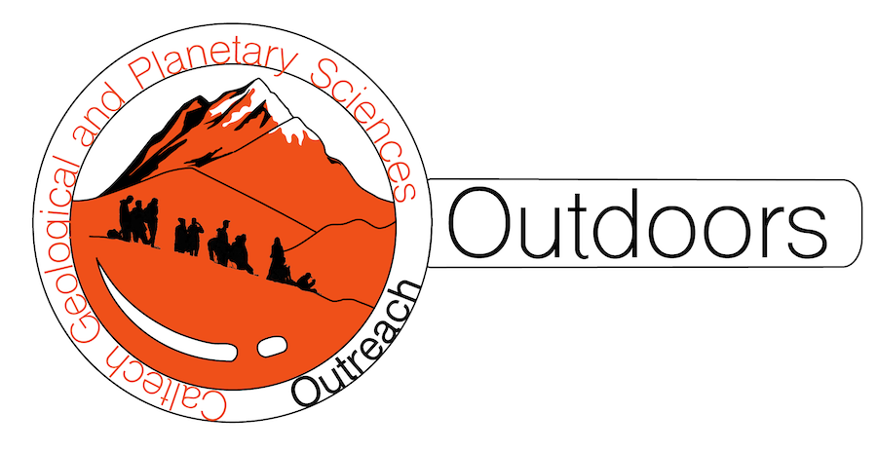
*Note: sections of the lesson plan template marked with * are optional, but may be useful for your planning: for example, if you are planning a field trip.
How rocks record Earth’s climate
Grade level | 6-8
Standards | MS-ESS2-2. Construct an explanation based on evidence for how geoscience processes have changed Earth's surface at varying time and spatial scales.  MS-ESS3-5. Ask questions to clarify evidence of the factors that have caused the rise in global temperatures over the past century.
Goals | - Students will observe and describe features of rocks and fossils.  - Students will identify ways that rocks and fossils contain information about the Earth’s past environments.
Time | 1 hour
# students | 5-40
Materials | - Large rock samples brought for display OR photographs (included below)  - Smaller rock samples for the groups of students to handle OR photographs (included below)  - 1 copy of the handout for each student (included below)  - 1 copy of photos for location 1-3 for each group (included below)  - Hand lenses or magnifying glasses (optional)
*Location | Classroom
*Logistics
*Caltech student needed? | Optional
*Accessibility | No accessibility concerns
Lesson activities
Engage: (5 min)
- Students have most likely heard about climate change. Introduce the topic of climate change, and ask one or two students to share something they know about it.
- To know how the climate is changing, we need to know what Earth as like in the past! Ask students to brainstorm ways that we are able to know about Earth’s past. With students’ answers, create a “mind map” or “word cloud” on the board.

Group activity 1: (10 min)
- Organize students into small groups of 2-4. Provide each group with one or more fossils and/or fossil photos to look at. These samples are representative of different past climates: for example, warm/tropical (e.g., a palm plant), hot/desert (e.g., mud cracks or snake fossil photo), or cold/ice age (e.g., mammoth footprints or skeleton).
- Ask students to describe and discuss what they see using the handout.
- Ask students to discuss what kind of place this sample could have come from and make some notes on the handout.

Share and discuss 1: (10 min)
- Invite students to share out to the class what they noticed about their fossils, and where they might have come from.
- With 2-3 fossils, play “four corners.” Students should move to one corner of the room depending on what they think the answer is. Example question: “do you think this fossil formed in: an ice age, a desert, a tropical place, or the ocean?” Once students have chosen their answer, ask them to explain why they think so.

Group activity 2: (10 min)
- Organize students back into small groups of 2-4. Provide each group with one or more rocks and/or rock photos to look at. These samples are representative of different types of geological environments: rocky mountainsides like the San Gabriel Mountains (e.g., a gravel conglomerate), beaches like California’s coast (e.g., a sandstone with ripples), and the deep ocean (e.g., a shale with marine fossils).
- Each group should also have one copy of location pictures 1-3 to share.
- Ask students to describe and discuss what they see using the handout.
- Ask students to discuss what kind of place this sample could have come from: location 1, location 2, or location 3? Students can place the fossil or fossil photo on the picture of the corresponding environment.

Share and discuss 2: (10 min)
- Invite students to share out to the class what they noticed about their rocks, and where they might have come from.
- With 2-3 rock examples, play “four corners.” Students should move to one corner of the room depending on what they think the answer is. Example question: “do you think this rock formed in: the side of a mountain, the beach, the bottom of the ocean, or the rainforest?” Once students have chosen their answer, ask them to explain why they think so.

Wrap up: (5 min)
- Go back to the word cloud or mind map created at the beginning of class. Ask students if they have any ideas to add.

Optional extension activities
- Encourage walks/hikes with their family to local trails (e.g., Eaton Canyon, Arroyo Seco, or the beach) that would show modern sedimentary environments. Suggest that students notice that different locations have different types of rocks, plants, and animals, and how those might relate to climate and elevation
- Visit the La Brea tar pits!
*Common misconceptions about the lesson

It may be confusing that the environment that rocks represent is not the same as the environment where those rocks are found today. For example, in the Midwestern United States today, we can find rocks from a tropical ocean environment! When we look at sedimentary rock samples or fossils, they were sampled from a larger body of rock called an “outcrop” where lots of similar rock has been uplifted above Earth’s surface. The rock in an outcrop was deposited as sediment (loose material) at the same location over time, from bottom to top, like layers in a growing cake. However, for that original loose material to become rock, it needs to be buried, and it may be below the surface and moved around by plate tectonics for millions of years before it is uplifted again to where we can see it. Over that time, Earth’s climate and the location of tectonic plates can change completely!

Students may be curious to know how changes in Earth’s past climate compare to the climate change that is occurring today. It is important to note that while the Earth’s climate has always changed, today the change is happening faster than ever before in Earth’s history, and that is a result of human activity. Here is some more information on this topic: https://royalsociety.org/topics-policy/projects/climate-change-evidence-causes/question-6/
*Handouts are included below.

Seeing Earth’s history in rocks
Sample | What does it look like?  You might notice:  Pieces of animals or plants (which ones?)  Pebbles, large or small grains  Patterns that stick out of or indent into the rock | Where do you think it comes from?  A hot or cold place? A dry or wet place?  A mountain? A beach? A forest? Under the ocean?
Fossil 1
Fossil 2
Fossil 3
Rock 1
Rock 2
Rock 3

Location 1: San Gabriel Mountains, California
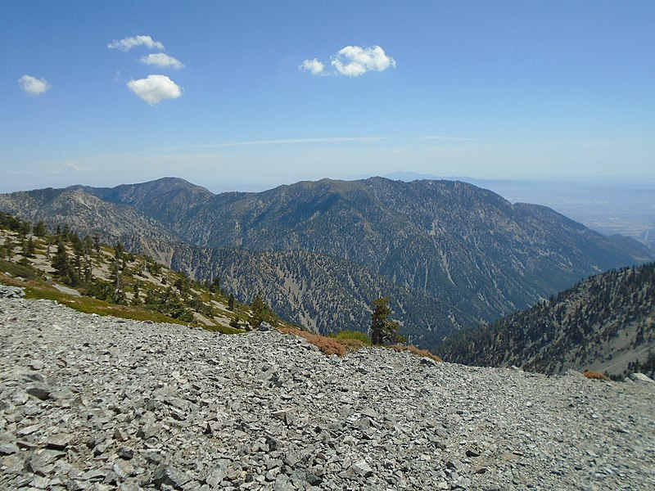
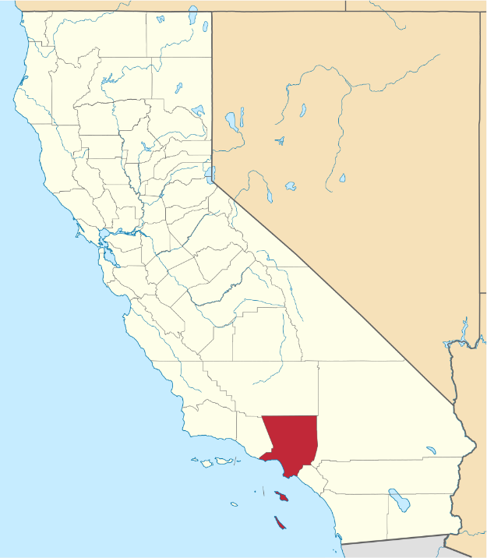
Location 2: Long Beach, California
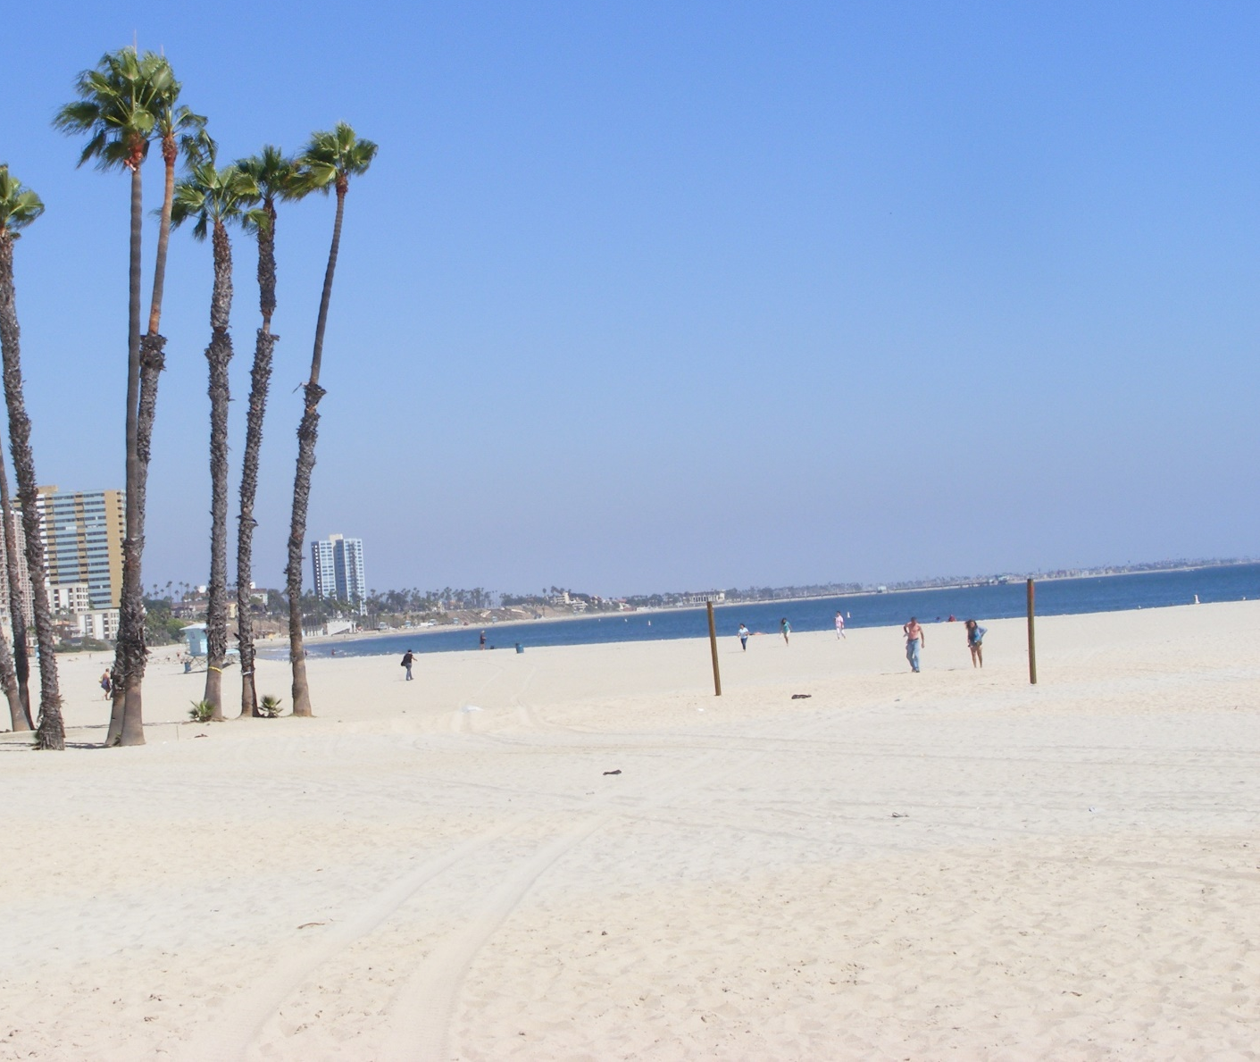
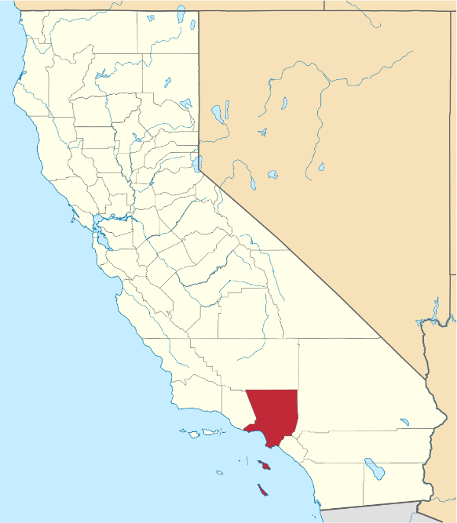
Location 3: the ocean floor