Renewable and Non-Renewable Energy

Imagining how old coal & oil might be, in twine…
→ Well, the largest ball of twine = 19,200,000 inch = 1,600,000 ft = 303 miles!
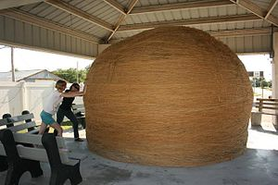
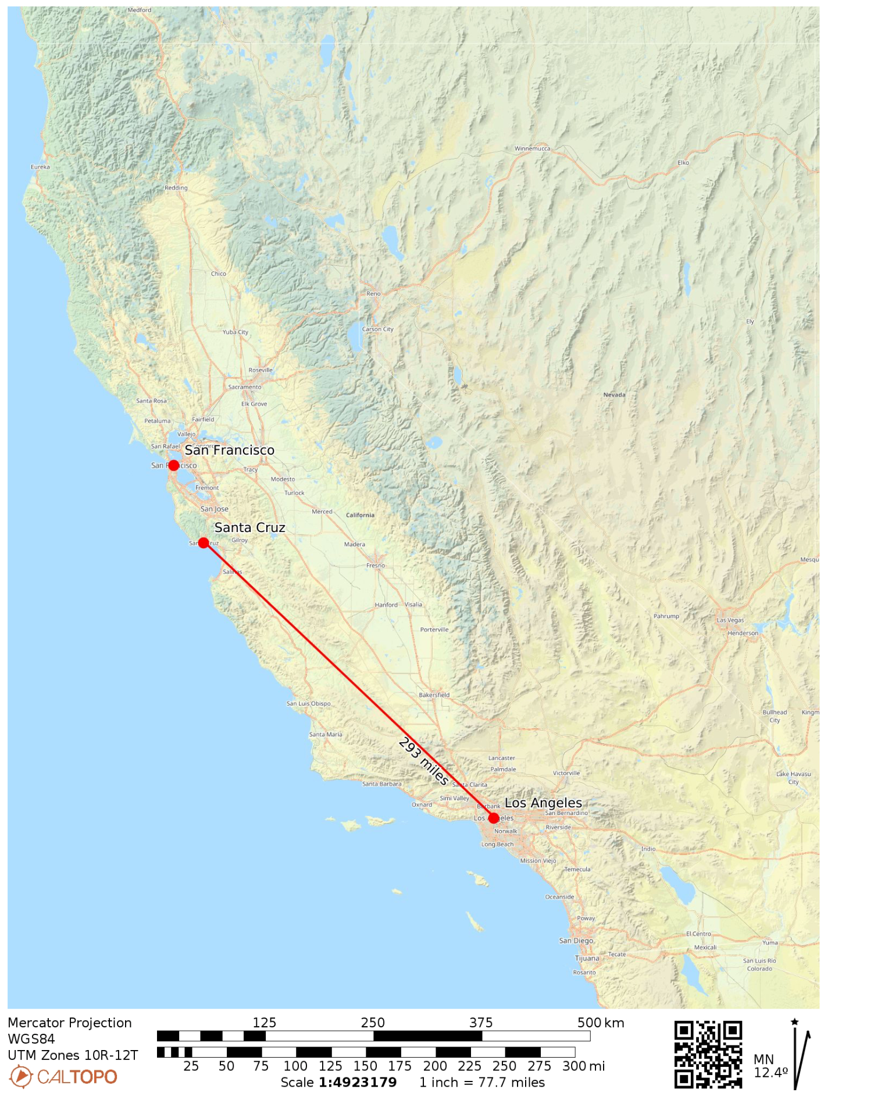
Largest community-rolled ball of twine, located in Cawker City, Kansas (2013). Wikipedia.

If you unrolled this ball of twine, it would stretch from Los Angeles to Santa Cruz and there would still be 10 miles of twine left over.

Map: https://caltopo.com/p/0P0S0

HYDROPOWER ACTIVITY - Instructions for making a water wheel

We’re going to start with a few semi-constructed pieces, including a wooden bbq skewer with two corks attached, one at the middle and one at the end. The middle cork has four slits cut into it.

We also have 4 plastic panels (built from recycled plastic bottles!), 2 paper clips, duct tape, string, a large bucket, and a small bucket.

- First we need to attach the plastic panels to the middle cork, wedging each one into its own cut slit in the cork. These will be our propellers, so let’s make sure they curve the same way!
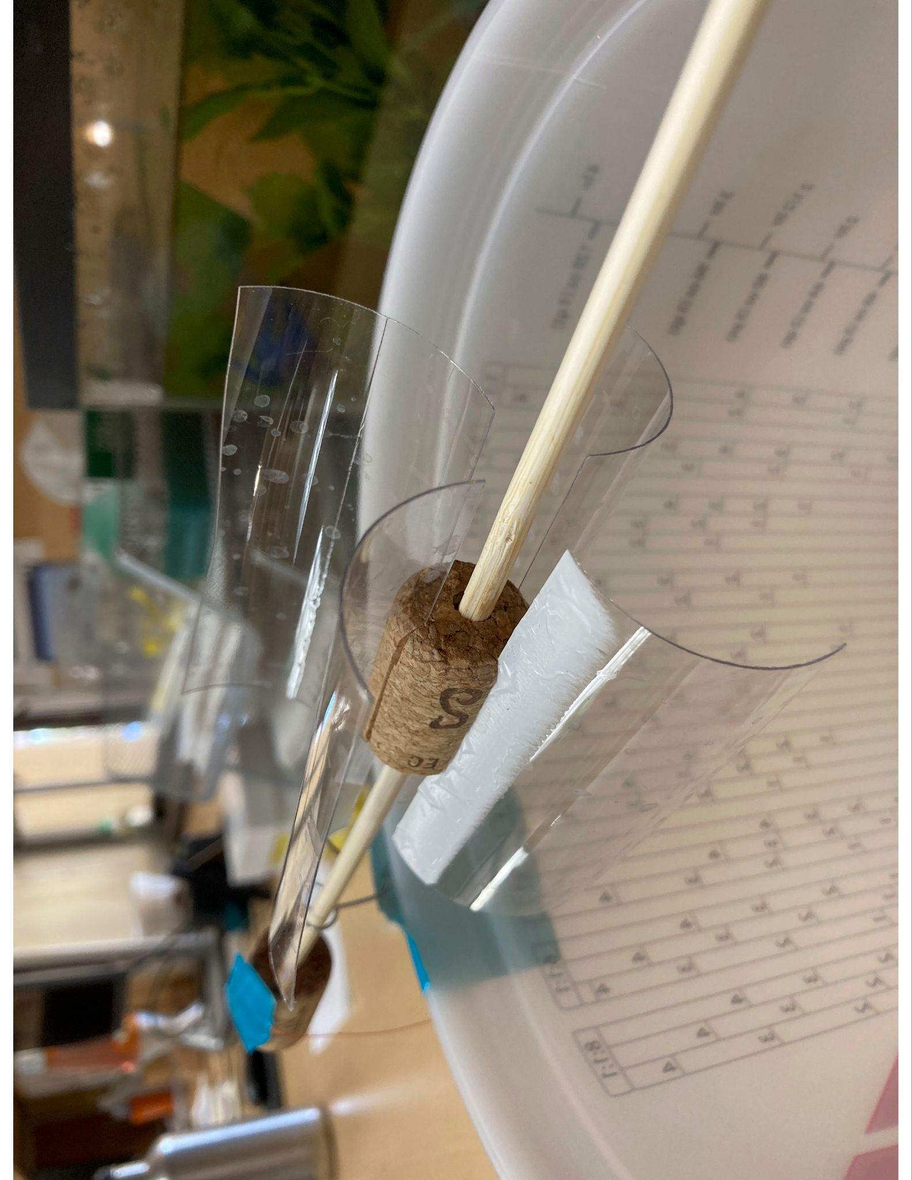

- Next, bend the paper clips into a small loop at one end so that they can be taped to the bucket and hold the bbq skewer straight across the large bucket. They don’t have to be perfect, and you can see that you might need to bend them around the skewer if you want to keep the corks on.

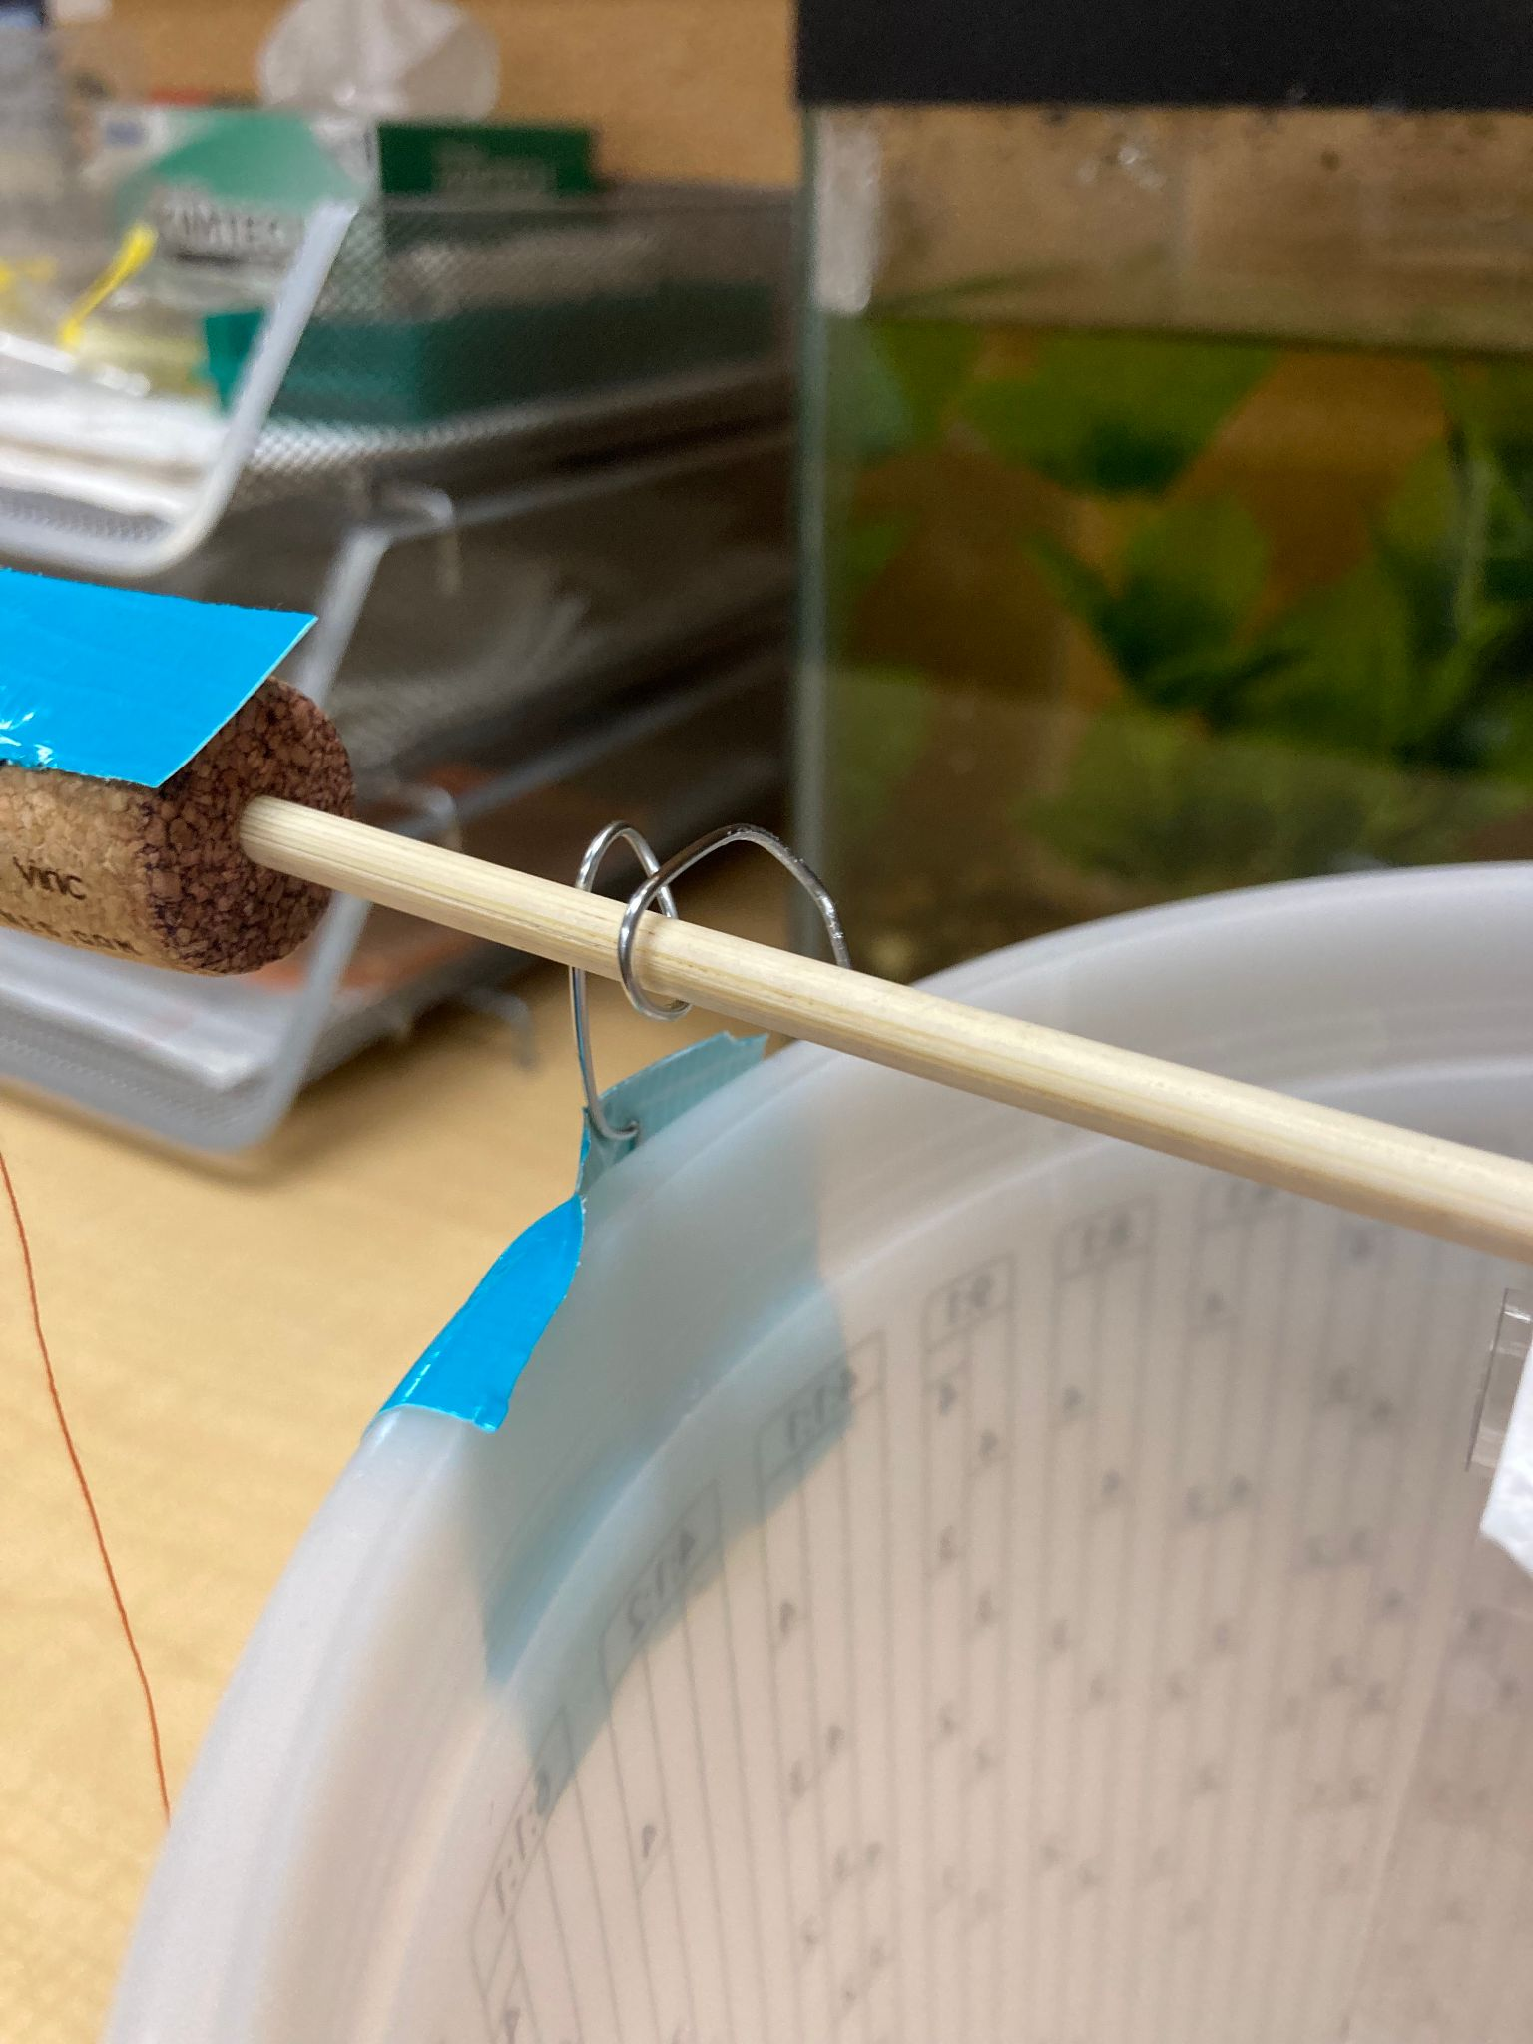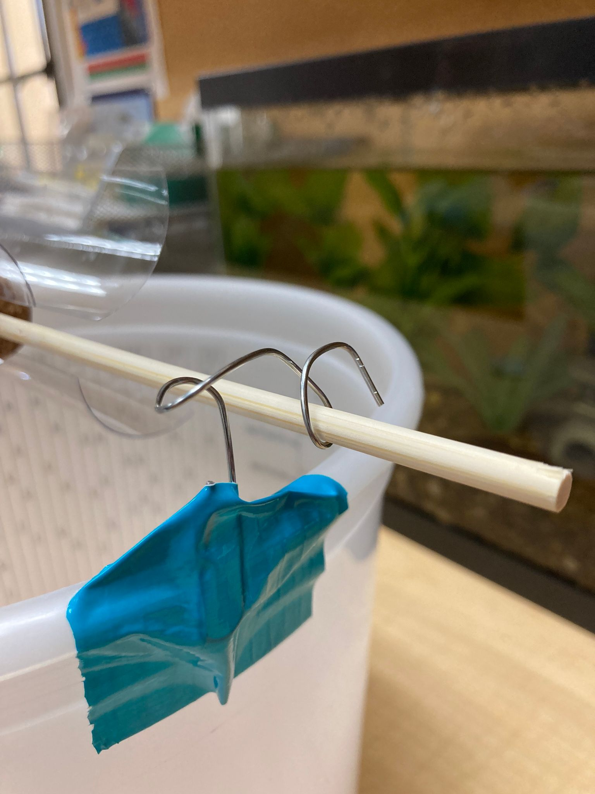
- Tape the paper clips on opposite sides of the large bucket, holding the bbq skewer.
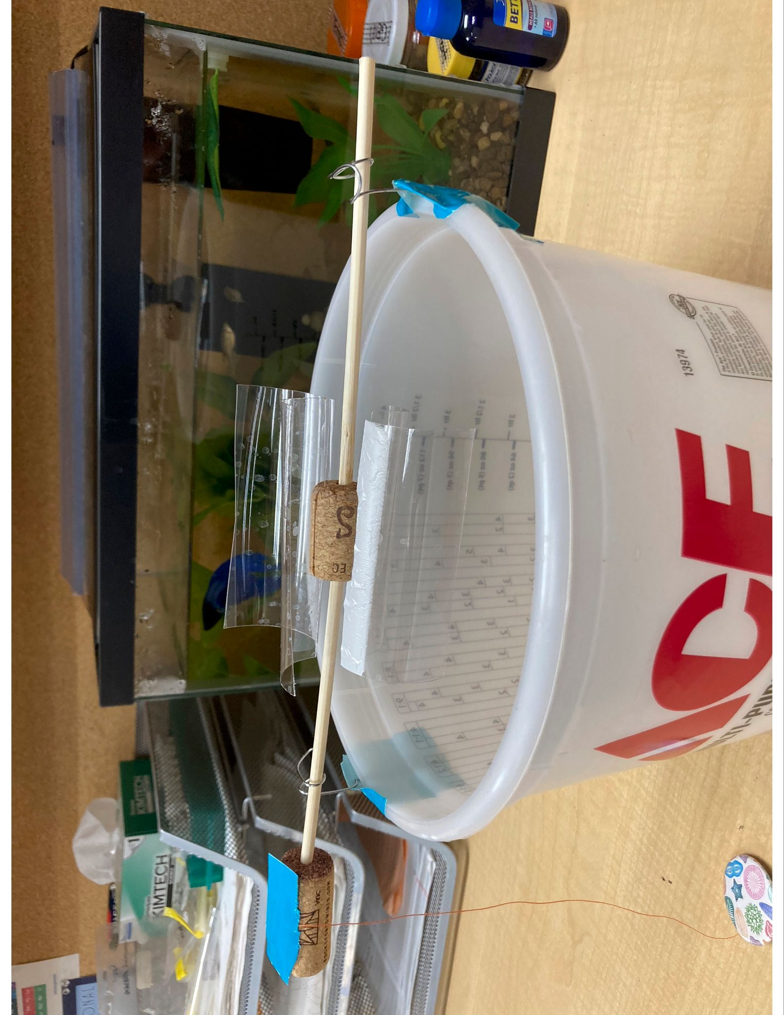

- Lastly, tape a piece of string onto the end cork, with enough room to tie an object onto the bottom, but maybe not too much room…

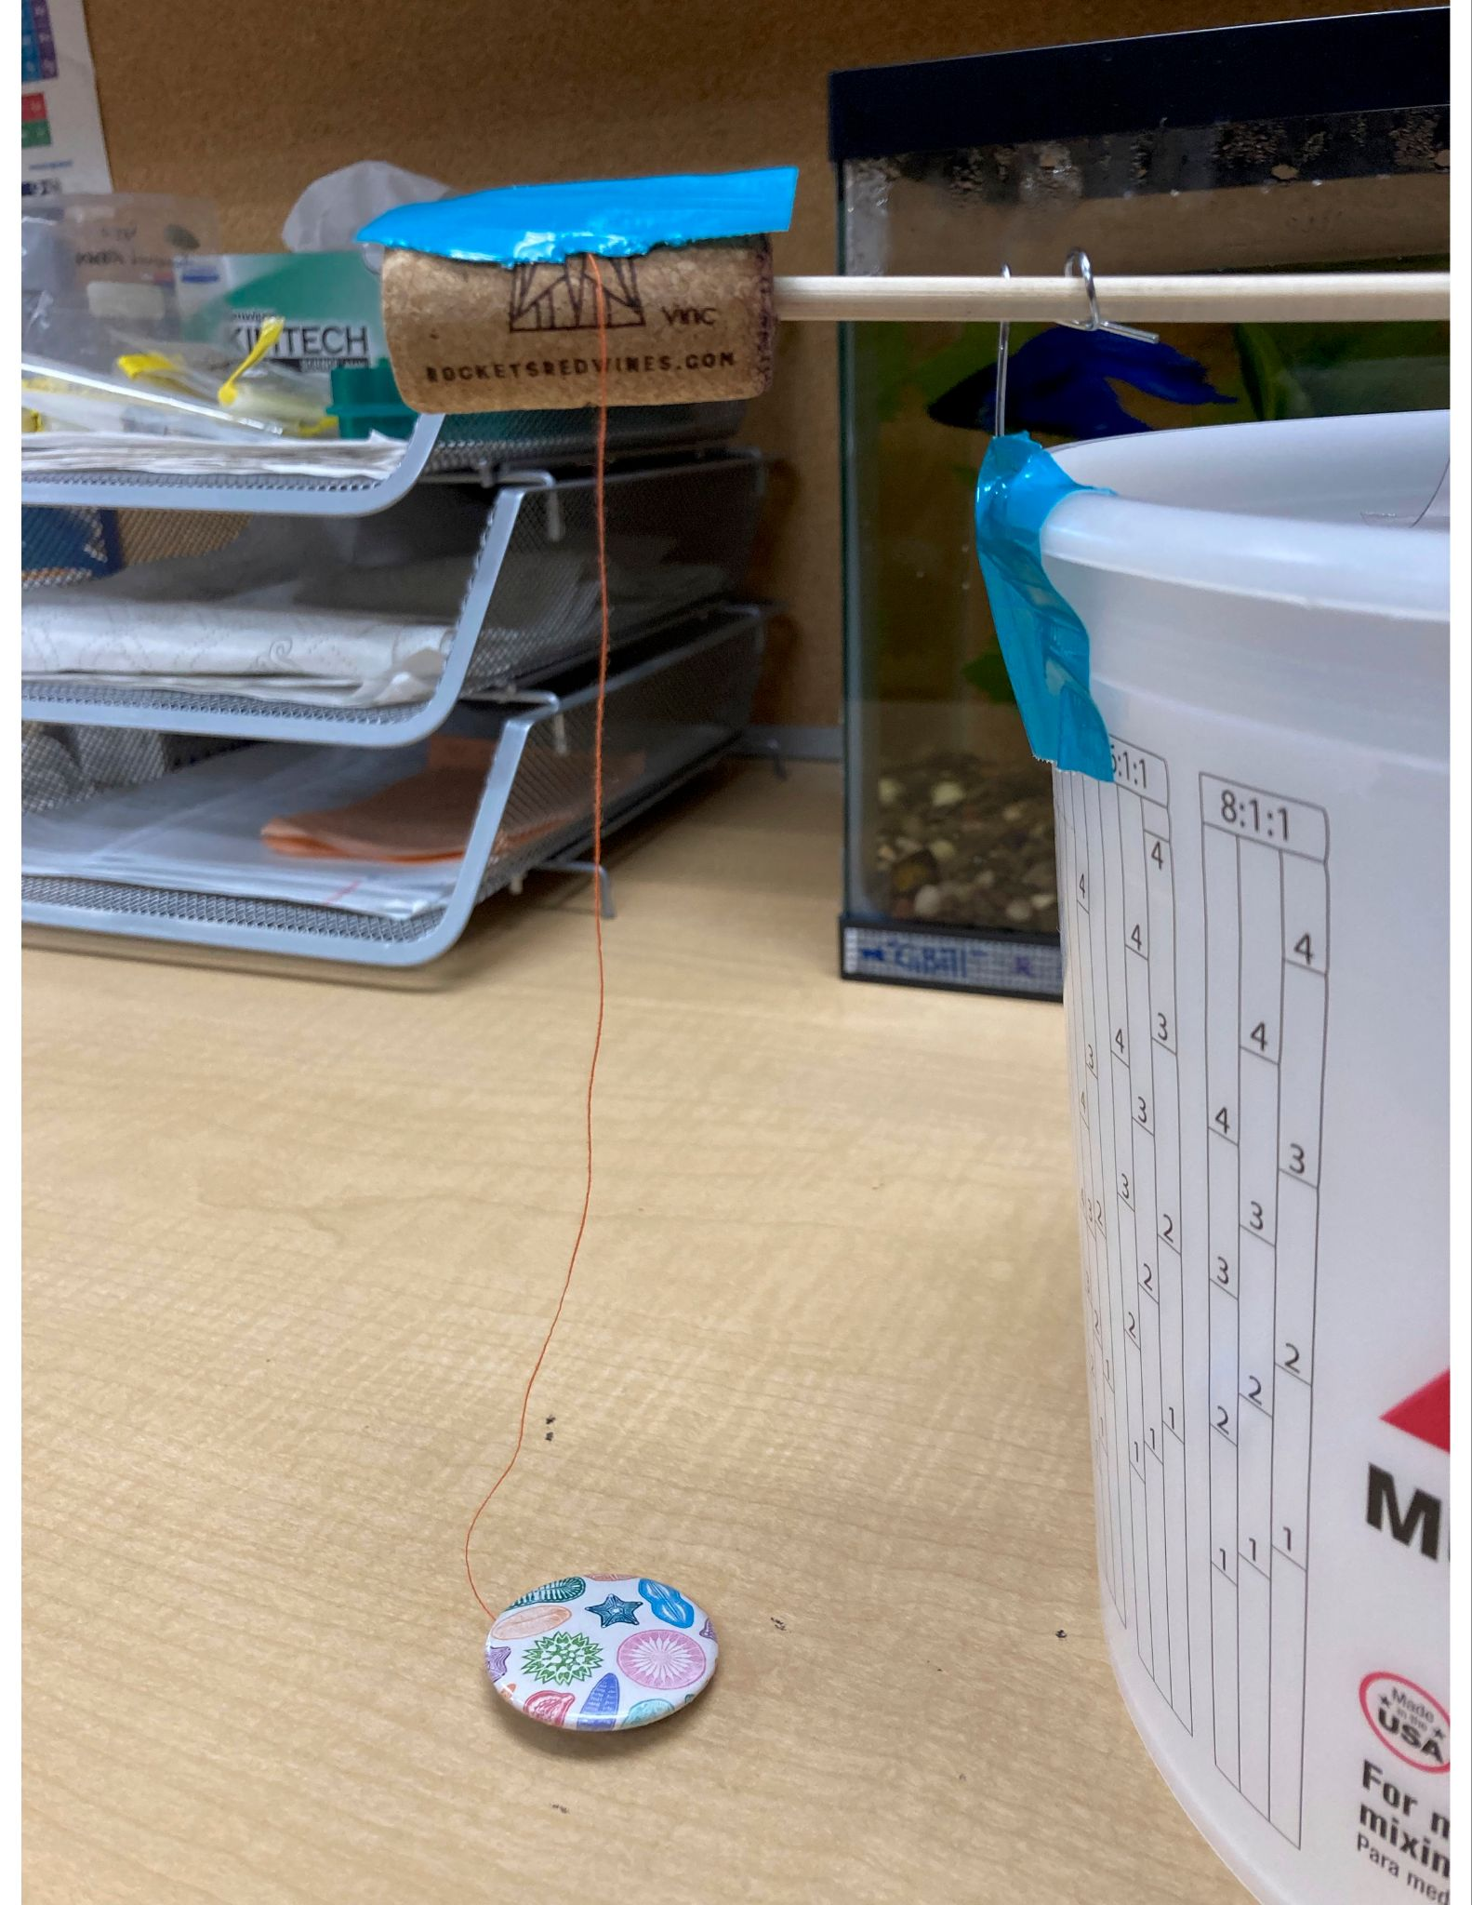

Hydropower Experiment Observations
What do you expect to happen with your experiment using the water wheel?
What object are you lifting with your water wheel? Describe it in words and/or a picture
How does the total amount of water used affect the water wheel?
How does the flow of water (for example, how quickly you pour) affect how the object is lifted?
Was your object easier or harder to lift than another team’s object? Why? How does that relate to the energy used to lift it?
Did the experiment match your expectation? Why or why not?

