  
**\*Note:** sections of the lesson plan template marked with * are optional, but may be useful for your planning: for example, if you are planning a field trip.

**Note:** This lesson plan is adapted from UCAR’s “[Radiation and Albedo Experiment](https://scied.ucar.edu/activity/radiation-albedo)”

| **Exploring the effects of sunshine**  **on Earth’s surface** | |
| --- | --- |
| **Grade level** | 6-8 |
| **Standards** | MS-PS4-2. Develop and use a model to describe that waves are reflected, absorbed, or transmitted through various materials.  HS-ESS2-4. Use a model to describe how variations in the flow of energy into and out of Earth’s systems result in changes in climate |
| **Goals** | -Students will observe how the characteristics of Earth’s materials impacts their temperature in the sun  -Students will compare their experimental model to different environments in Los Angeles to investigate how albedo affects climate |
| **Time** | 1 hour |
| **# students** | Groups of 3-5 |
| **Materials for Each Group** | For each group:  - Three pie pans or dishes  - White colored sand  - Black colored sand  - Water  - One instant-read meat thermometer  - Reflector lamp (or regular desk lamp) with incandescent light bulb  - Optional: graph paper |
| **\*Location** | Classroom/Lab Space |
| **\*Logistics** |  |
| **\*Caltech student needed?** | Optional |
| **\*Accessibility** | No accessibility concerns |
| **Lesson activities**  **Introduction: (10 min)**  - Students have most likely already thought about how the color and type of material affects how it warms up in sunshine (and how it cools down at night). For example, ask students, "When it is a hot day, what color shirt would you wear to keep cool and why?” and "During the summer, what does it feel like to walk on asphalt or gravel with no shoes?"  -How would it feel to walk barefoot on surfaces A, B, and C in this photo?    Photo credit: Pacific Park, 2024.  - Optional set of slides with background information on heat transfer and heat capacity  - Explain that, in this activity, they will explore how different types of surfaces found at the Earth's surface (such as sand, soil, and water) heat up when the Sun's energy reaches them, and how they cool down when out of the sunshine.  - Note that this experiment uses materials to model sunshine and Earth materials. Show students the materials and explain how each relates to the Earth system. (The lamp represents the Sun in this model. The sand represents beaches, sand dunes, and rocks. The potting soil represents large areas of soil outdoors. The water represents lakes, rivers, and the ocean.)  -Invite students to form a hypothesis about which material will heat up the most during the experiment.  **Preparation: (5 min)**  - Organize students into small groups of 3-5. Provide each group with the materials listed above  - Fill the pans/dishes to the same level, one with dark sand, one with light sand, and one with water. (If small groups are doing this activity on their own, distribute supplies to students.)  - Place the pie pans on a table or desk and position the lamp about 12 inches above them. (Do not turn on the lamp yet.)  - Provide students with data tables (following pages) - designate a recorder for each group  -Instruct students on how to use/read the thermometers.  Lamp shining over three dishes with thermometers in them. The dishes contain water, light soil, and dark soil.  **Activity: (10 min)**   * Have students record the temperature right before they turn on the lamp (Time=0), entering the number into their data table. * Turn on the lamp and instruct students to record the temperature every minute in the three pie pans for ten minutes. * After ten minutes, turn the lamp off.   **Observations and Questions: (10 min)**  - Invite students to answer and discuss the questions on the handout.  - Have groups compare their filled-out temperature charts as they discuss findings.  - Optional: Students may graph the temperature data for each material using graph paper and colored pencils. Students can write captions for their graph that describes how the three different materials change in temperature over time.  **Wrap up: (10 min)**  - Formally present the definition of albedo and review answers that each group got for the questions  **Optional extension activities**  - Have students design and conduct their own research into the influence of surfaces on temperature, comparing Earth surfaces that interest them (such as colored soils, dry and wet soils, grass, dry leaves, or different types of coverings such as plastic or aluminum foil). Have students compare the data with these new surfaces compared to the given surfaces (water, light soil, dark soil). Note that the data may not be comparable due to variations in experimental design, such as differences in light bulb temperature and height of the lamp. | |
| **\*Definitions, background information, and common misconceptions about the lesson**  **-Albedo: The fraction of sunlight reflected by a surface**. Albedo of 1 means all light is reflected as light. Albedo of 0 means all light energy is absorbed and radiated back as heat. (A material with an albedo of 0 is known as a black body.)  - Winter is colder because of the reduced hours of sunlight and because the sunlight is coming in at a steep angle through the atmosphere, which allows it to absorb more light before reaching the surface.  - Snow, ice, and clouds all have high albedo | |
| **\*Handouts** are included below. | |

**Temperature Data Table**

| **Minute** | **Water Temperature** | **Light Sand Temperature** | **Dark Sand Temperature** |
| --- | --- | --- | --- |
| 0 (Record, then turn light on!) |  |  |  |
| 1 |  |  |  |
| 2 |  |  |  |
| 3 |  |  |  |
| 4 |  |  |  |
| 5 |  |  |  |
| 6 |  |  |  |
| 7 |  |  |  |
| 8 |  |  |  |
| 9 |  |  |  |
| 10 |  |  |  |

**Observations and Questions**

1. **Which material heated up the most in ten minutes?**
2. **Look at the three locations in Pasadena marked in the map below. Which location is probably the hottest in the summer?**

* **(A) Swimming pool**
* **(B) Parking lot**
* **(C) Park**

**Why did you choose this location?**



1. **Climate change and the albedo effect:**
   1. **These photos are of the San Gabriel Mountains northwest of Pasadena. One photo shows the mountains before a snowfall, and the other shows the mountains after a snowfall.**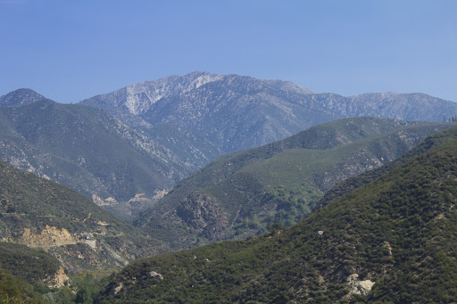

**Photo credits: left: Hike-Los Angeles; right: California Curated**

* + 1. **Based on the color of the mountain surface, which one do you think will be heated up more in the sun?**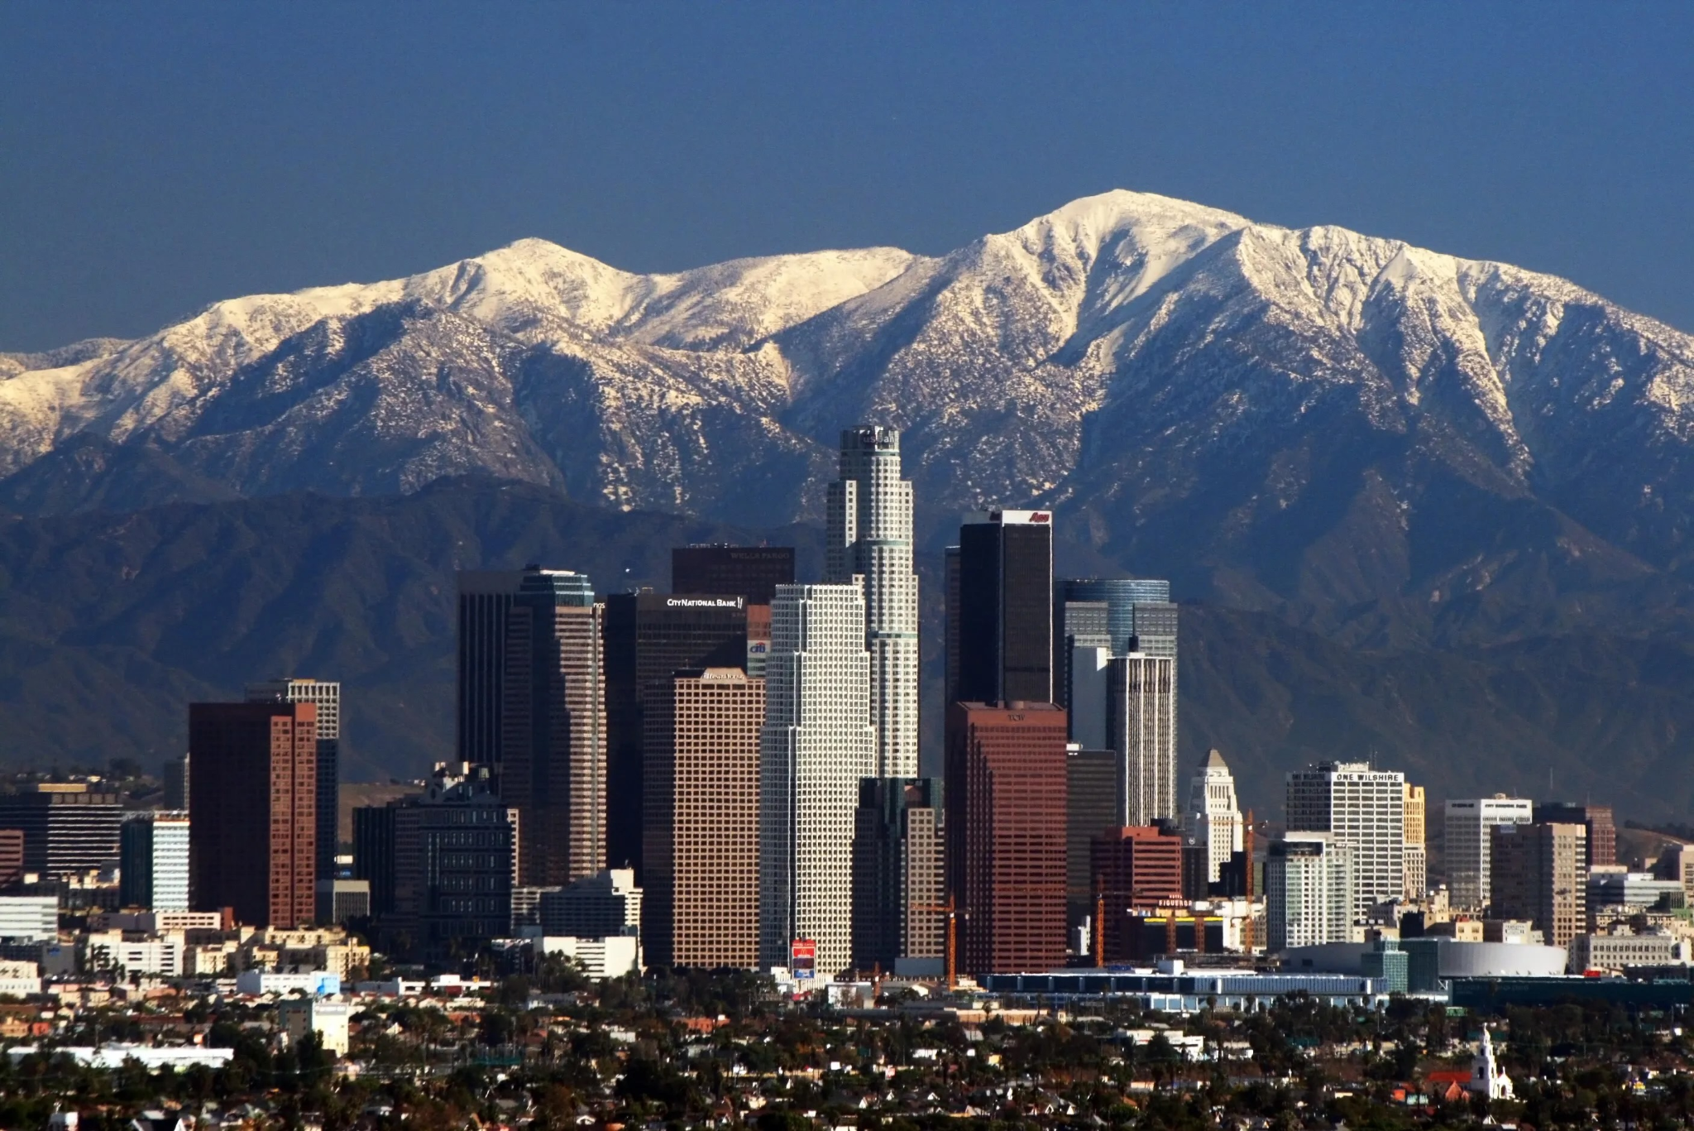

* + 1. **Climate change is causing glaciers (white and icy surfaces) to melt away all over the world. If these bright white surfaces are lost, how do you think it could affect global temperatures?**

* 1. **In some places in Los Angeles, dark-colored streets are being painted white. Do you expect that a light-colored street will absorb more or less heat than a dark-colored street?   
     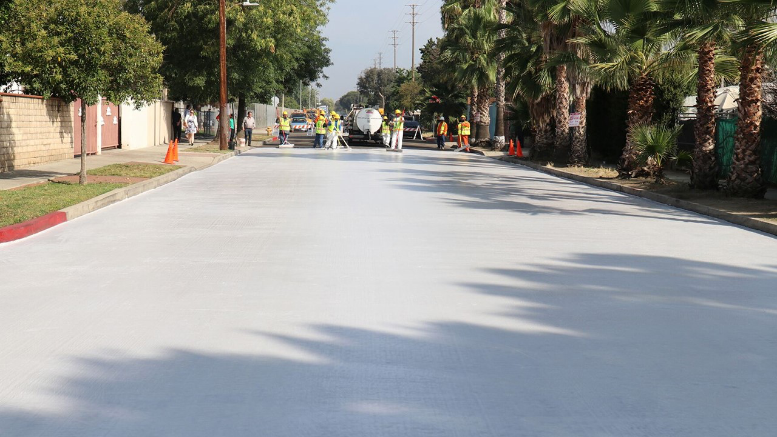**image credit: Bureau of Street Services